**Muhammad Toqeer**

**Q#1**

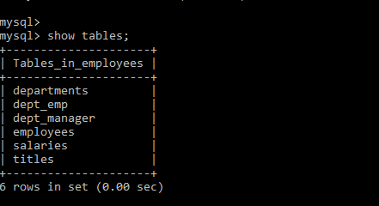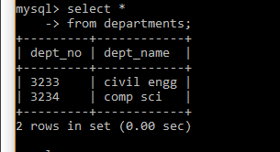**Part1:**

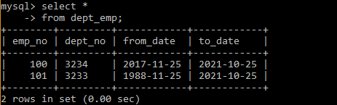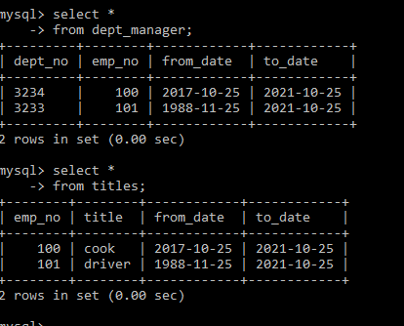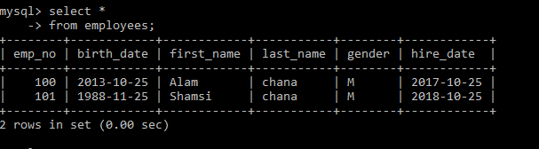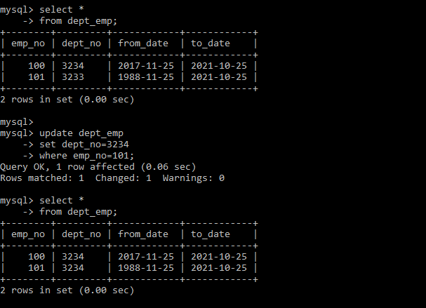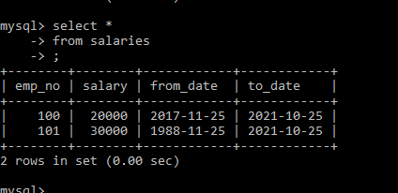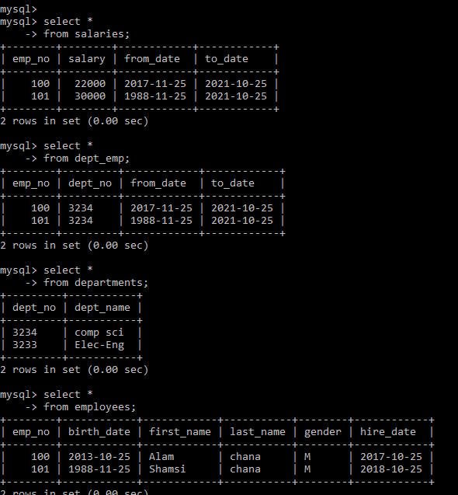

**Q#2**

1. Create a database named “pharma”.
2. Create tables with the primary and foreign key constrains as shown (with on cascade update and delete).

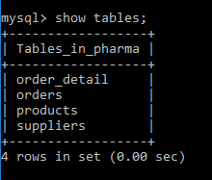

1. 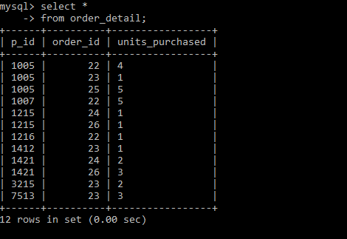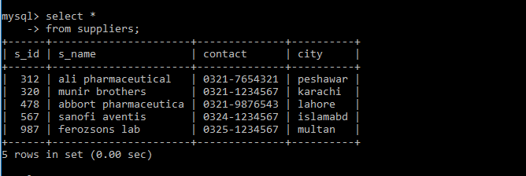Insert the data as shown.

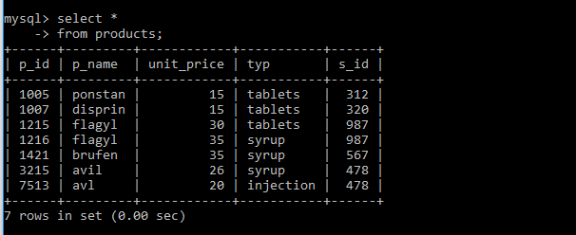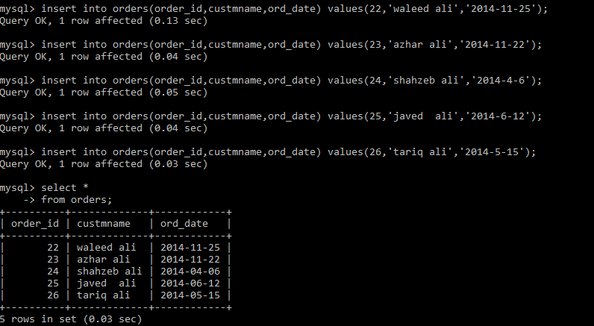

1. Change the name of supplier named Munir Brothers to Muneer Brother.

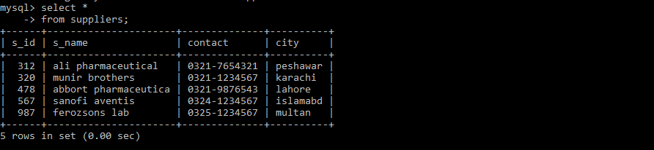

1. Delete the Avil syrup product from the product table, does it affect order_detail table? If yes then how? If no then why?

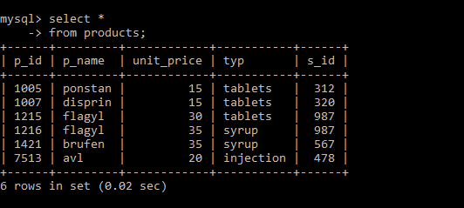

1. Set unit_price to 40 for all the products whose type is “Tablets”

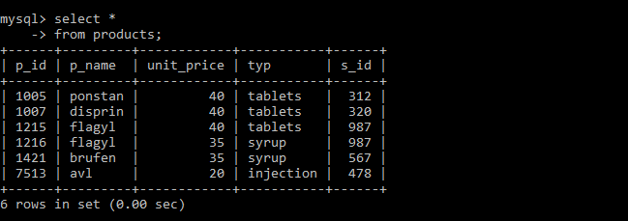

1. Delete the order with the order _id 22 from the orders table, does it affect order_detail table? If yes then how? If no then why?

